25.70: a) 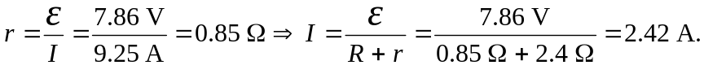
b)
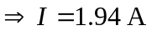
c) The terminal voltage at this current is

